**1. spring-rest-handson**

Create a Spring Web Project using Maven:

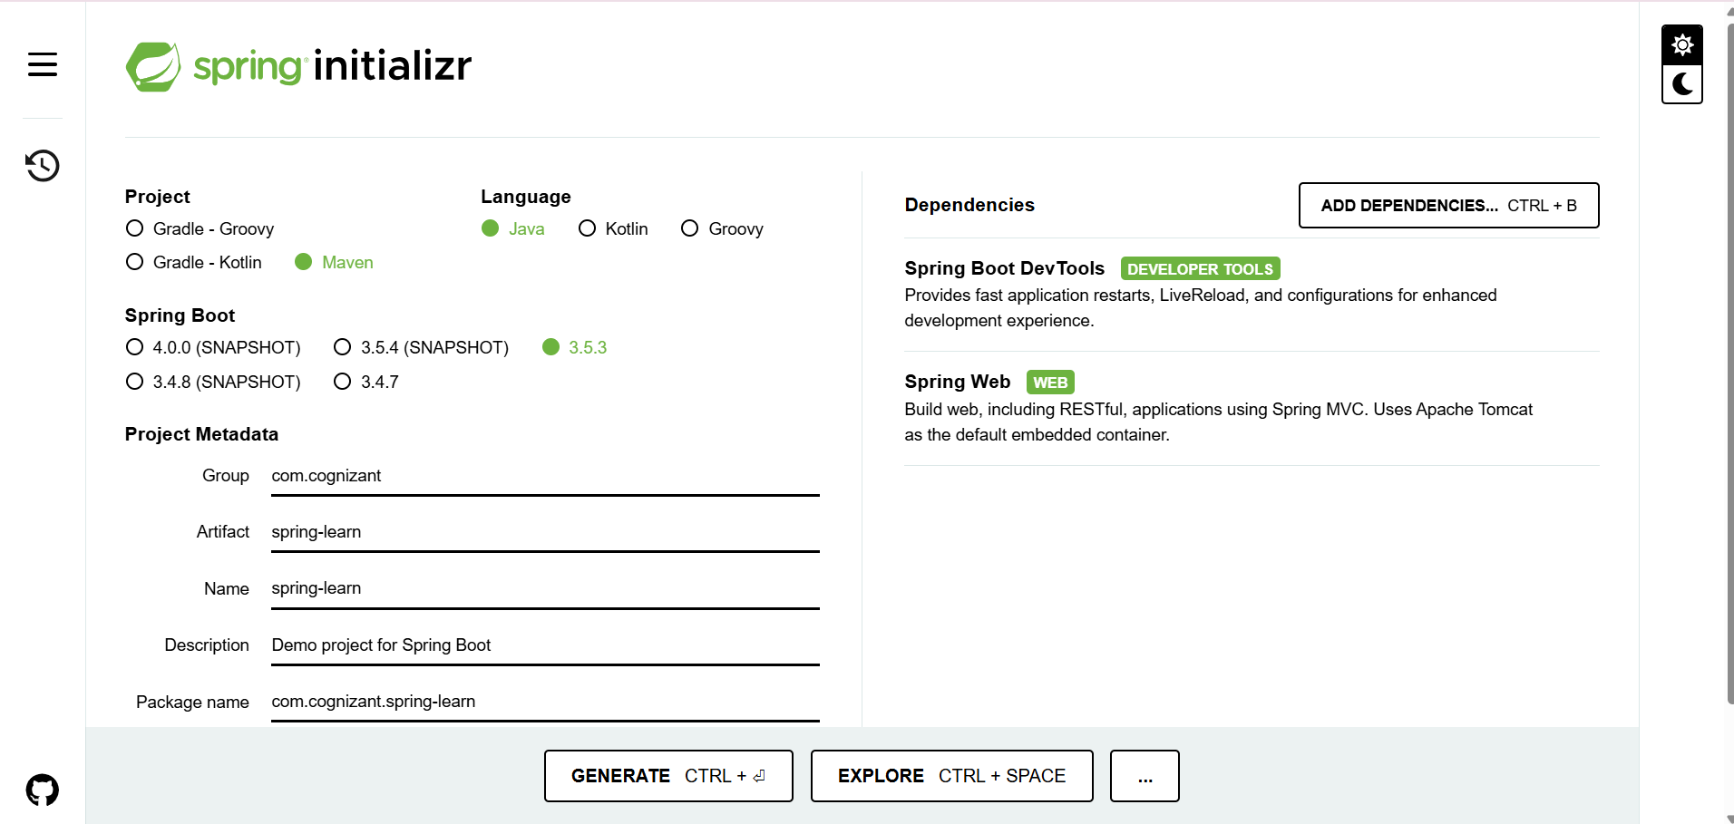

**SpringLearnApplication.java:**

package com.cognizant.spring_learn;

import org.springframework.boot.SpringApplication;

import org.springframework.boot.autoconfigure.SpringBootApplication;

@SpringBootApplication

public class SpringLearnApplication {

public static void main(String[] args) {

SpringApplication.run(SpringLearnApplication.class, args);

}

}

**HelloController.java:**

package com.cognizant.spring_learn;

import org.springframework.web.bind.annotation.GetMapping;

import org.springframework.web.bind.annotation.RestController;

@RestController

public class HelloController {

@GetMapping("/hello")

public String hello() {

return "Hello from Spring Web!";

}

}

**Application.properties:**

server.port=8090

